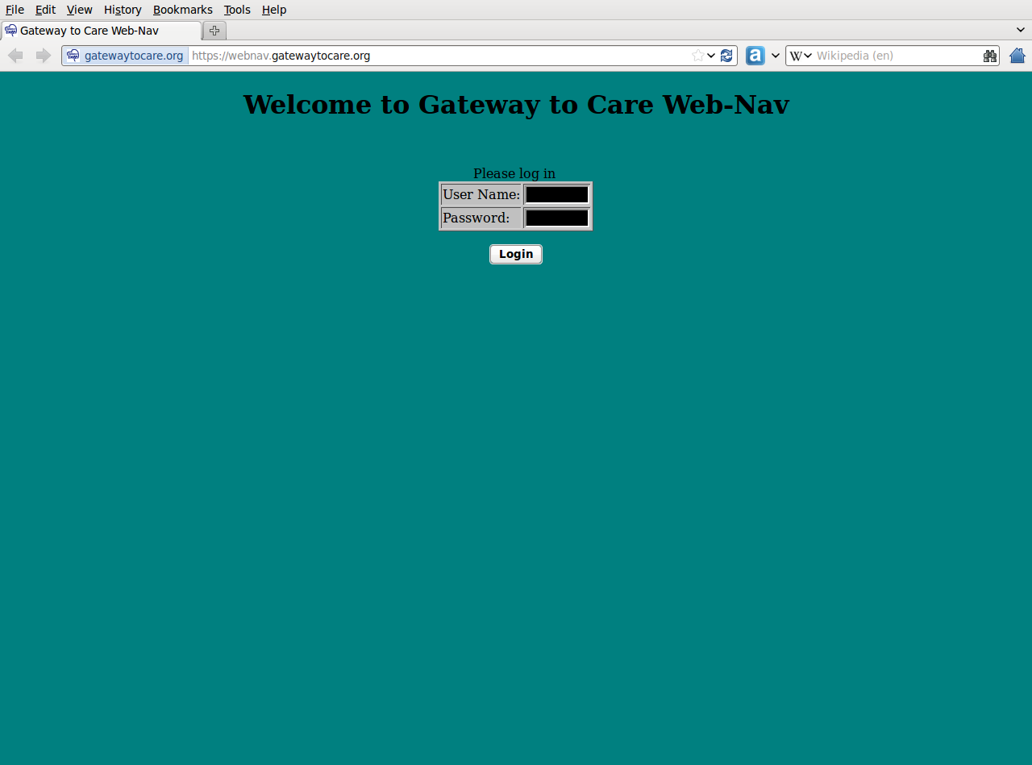
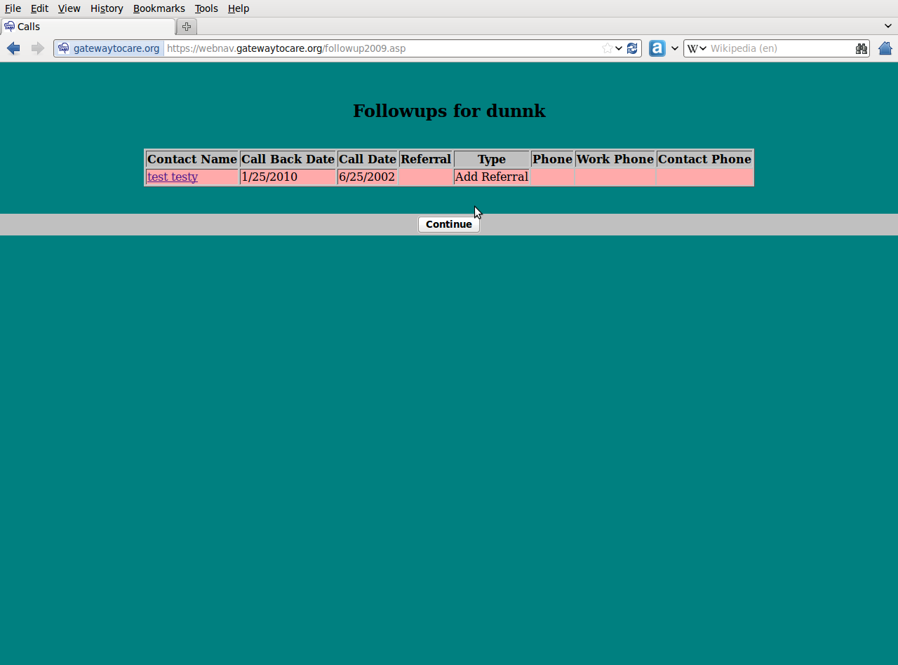
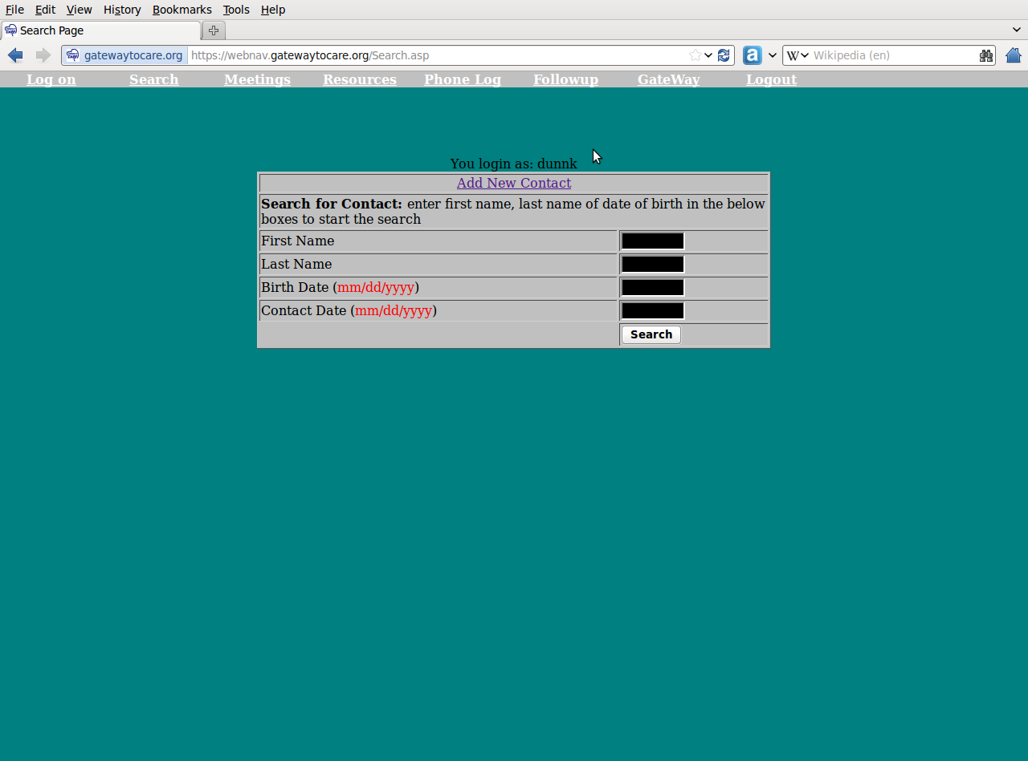
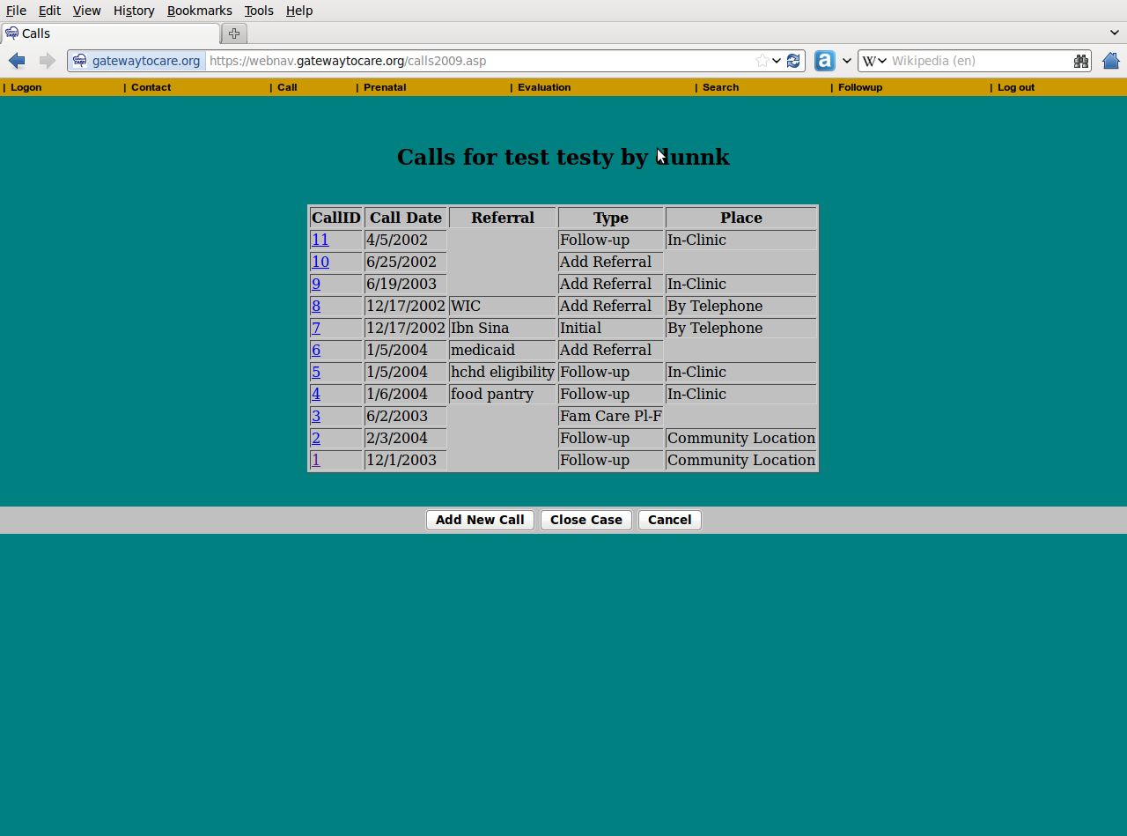
CONCEPTS
- Flexibility is mandatory! Required fields are limited. Not everyone will use every screen.
- Each User has a number, but numbers can be grouped – supervisor can get aggregated information based on their group (Users assigned to them). PHN will be one such group.
- As information changes over time, old info is stored in order to have history – no overwrite of addresses, phone numbers and other information so have both current and old, with current the default view
- Allow User to transfer a case they “own” to another person within group without administrative intervention
  - If User not able to transfer, this is a function of the supervisor/group manager.
  - Only Demographic information is changed…all other remains with original User. Only original User can access “Calls” although the new User can see some information through the “find call” screen.
- Users placed in defined group and a manager can see group level information for all members/broken down by member
- All items shown as “Drop-Down” will be editable by Database Manager (DBM)
- Database Manager only via SQL – easy way to combine accounts when duplicates created that cover all tables in one process
- Allow uploads of documents and attachment to a case

Contact Reference (groups) is used to categorize reason for interaction/intervention.

This will be a drop-down field, and the list is editable by DBM. At time this is defined, need to be able to also add specific extra fields based on the reference – such as if MHHS is chosen, there will be one extra field to state which hospital person was at. If HISD FSA is chosen, there will be two extra fields generated to put in position and location. There will also be one or more descriptions that can be made mandatory, based on the reference chosen.

Last Contact Reference will be shown on the call screen and if necessary, can be changed to another option that is listed in the table for that contact – not any of the available options

All Referrals will be put into a single table connected with date (from call table) and ContactID, whether the entry is from the Assessment Screen or the Call Screen.

INPUTS
(Each bold indicates a new input screen)
Required Fields marked by *
DEMOGRAPHIC
ContactID auto-assigned in background
First Name *
Last Name *
Date of Birth *
Address include historical tracking Includes Street, Apt, City, State, Zip
Phone
Include home, work, cell include historical tracking (each)
Email Address include historical tracking
Include drop-down for personal/business
Preferred Method of contact [new drop down from home/work/cell/email/text/letter]
Race/Ethnicity [drop-down]
Language Spoken in home [drop-down]
Immigrant [drop-down]
Homeless [Bool Yes/No] *
Out of County [Bool Yes/No]*
Type of Resources currently in place [drop-down] *
ER visits in past 6 months include date stamp
Patient’s Stated Health Home * multiple so can track
Number of People in Family
Contact Reference * (Group) include date stamp
Reference Number (may or not be mandatory/depends on ref) include date stamp
Extra Field 1 [Used based on Contact Reference]
Extra Field 2 [Used based on Contact Reference]
Contact Date (default to today but overwritable)
Create Date (background) – system management
Last Update (background) – system management

FAMILY
Family ContactID Unique for each family unit (suto-assign)
ContactID Auto-assigned to each family member
First Name *
Last Name *
Date of Birth *
Relationship [drop-down]
Type of Resource currently in place [drop-down]
Caregiver/Care Recipient [drop-down]
Chronic Disease [yes/no] If yes -
Specify type
Create Date (background)
Last Update (background)

ASSESSMENT
For all: yes/no; if yes, referral is required
Need Health Home [yes/no; if yes, referral is necessary] Referral (note: could be multiple)
Need Insurance or other Access Referral (note: could be multiple)
Immunization status Referral (note: could be multiple)
Last Medical Checkup Date Referral (note: could be multiple)
Last Dental Checkup Date Referral (note: could be multiple)
Identified Visions Needs Referral (note: could be multiple)
Identified Behavioral Health Needs Referral (note: could be multiple)
Identified Food Needs Referral (note: could be multiple)
Eligible for WIC Referral (location)
Identified Housing (including Utilities) Needs Referral (note: could be multiple)
Identified Child Care Needs Referral (note: could be multiple)
Identified Legal Needs Referral (note: could be multiple)
Identified Transportation Issues Referral (note: could be multiple)
Referral to Social Work/Case Manager Referral (note: could be multiple)
Assessment Date
Create Date (background)
Link provided so that can access survey website easily, with contactID submitted to survey as unique identifier. Survey website is located at www.gatewaytocare.org/survey/admin/
CALLS
CallDate (default to today but overwritable) *
Pull up current Contact Reference from Demographic and show on screen
Pull up ContactID and show on screen
Type of Contact [drop-down] *
Place of Contact [drop-down] If Case Closed picked – jump to Case Close screen
Subject
Reason for Visit
Referral Additional referrals outside of assessment (could be multiple)
Notes
Call back Date (required unless case is being closed-set so have rules based on who are provided)
Extra Field 1
Extra Field 2
Only for ER visits (identified as ER in Place of Contact Field-mandatory)
ER Visit Complaint
Why ER and not Clinic?
How arrived at ER? [drop-down]
Create Date (background)

CASE CLOSED
Interview Date (background) Pull from Call Date
Established/Using Health Home [yes/no] *
Name of Health Home
Obtained Insurance [yes/no] *
Type of Insurance Obtained (drop-down)
Results
Education Provided
- Insurance member/nurse line [yes/no]
- Health Home Use (Includes HCHD) [yes/no]
- Ask Your Nurse [yes/no]
- Transportation Options [yes/no]
- Navigate payment of services option [yes/no]
- Other [yes/no] Specify
Answer if assisted with
- Eligibility ( State/Local) establishment/renewal [yes/no]
  - Medicaid
  - CHIP
  - HCHD
  - Other Local
- Transportation Options [yes/no]
- Change Insurance PCP [yes/no]
- Other eligibility [yes/no] Specify
If Unsuccessful, select reason [could be drop-down]
- Disconnected Phone
- 3 Messages left
- Patient refuse to speak
- Patient will not follow up
- Wrong Number
Rate Success of Encounter (successful/unsuccessful/mixed) *
Extra Field 1
Extra Field 2
Create Date (background)

PRENATAL
Last Period *
Est. Gestational Age *
# of Pregnancies *
# of Live Births
# of Stillbirths
# of Miscarrages
# of Abortions
Plan to Breastfeed? *
Taking Prenatal Vitamins *
Vitamin Follow-up
Live with baby’s father *
Physical Complaints *
Cigarettes – Self *
Cigarettes in House *
Education Provided on Dangers of:
- Caffeine [yes/no] have free text field if need in future
- Artificial Sweetener [yes/no] have free text field if need in future
- Alcohol [yes/no] have free text field if need in future
- Prescription Drug [yes/no] have free text field if need in future
- Over-the-Counter Drug [yes/no] have free text field if need in future
- Herbal/Alternative [yes/no] have free text field if need in future
- Cocaine [yes/no] have free text field if need in future
- Marijuana [yes/no] have free text field if need in future
- Heroin [yes/no] have free text field if need in future
- Sniffing/Huffing [yes/no] have free text field if need in future
Est. Delivery Date *
Actual Delivery Date
Extra Field 1
Extra Field 2
Create Date (background)
Modify Date (background)

EVALUATION (All REQUIRED except Notes and Extra Fields)
Evaluation Date
Satisfaction with Services received [drop-down]
Health Home for self
Health Home for other family members
ER visits since Navigation services
Would you/have you referred someone else for Navigation Services? [yes/no]
Notes
Have you used medical home in the last 6 months? [yes/no]
Who do you call if you are – or a child is –Sick?
How easy is it for you to get an appointment with your doctor/clinic? [new drop-down]
How easy is it for you to get there? [new drop-down]
Can you contact someone to answer questions after regular office hours? [yes/no]
Do you talk to your doctor /Clinic about ALL your health issues? [yes/no]
How does your doctor/clinic get feedback if you see another provider (including ER )? [new drop-down]
Did you feel the User really cared about you as a person?
Extra Field 1
Extra Field 2
Create Date (background)
DESIRE: Ability to change ownership of block of numbers to another person and then when everything is in, be able to revert back to original ownership
Link provided so that can access survey website easily, with contactID submitted to survey as unique identifier. Survey website is located at www.gatewaytocare.org/survey/admin/

MEETINGS/EVENTS
Name of Event *
Date of Meeting *
Estimated Interactions
Estimated Total Attendance *
Staff Members in Attendance
Summary
Create Date (background)

PHONE LOG
Type of Call (use same drop down as for reference)
# in Family
# With Insurance
# With Regular Doctor
ZIP code
Notes
Extra Field 1
Extra Field 2
Create Date (background)

FACILITATED PROGRAMS (All REQUIRED except Comments)
Title of Program
Facilitator
Location
Date
Start Time
End Time
Number of Participants
Series Week
Comments

Drop downs are control lines in one or more table that is modifiable by Database Manager
OUTPUTS
Flat file created and downloadable by group manager group
that includes all entries by group members

List of contacts to be followed-up ref, individual and group
NOTE: Like what we have now,
but if can, add crosstab with 1-30, 31-60, 61+ by user

List of contacts that have not been closed ref, individual and group
both list of names and only numbers
NOTE: Like Access “Query Contacts without Matching CaseClosed”

Count of calls in stated time period by call type ref, individual and group
NOTE: Like Access Query “Calls Crosstab with Names”

List of contacts in stated time period ref, individual and group
both list of names and only numbers
NOTE: Like Access Query “Contacts without Matching Calls”

List of calls by variable (date/user/reference) individual and group
both list of names and only numbers
NOTE: Like Access Query “Call Query by User” with new for date and reference

List of contacts with no calls individual and group
NOTE: Like Access Query “Contacts without Matching Calls”

All work for specific time frame individual
NOTE: Like Access Report “Monthly by User”

PHN WebNav Outline

Summary of PHN Database Purpose
The PHN database is used by multiple individuals to enter and record data pertaining to a patient's demographic, financial, social and medical history. Each patient referred to the provider health network is given a medical record number that is automatically generated and not duplicated in the system. While each patient will be identifiable by one single number each case may have multiple referrals and call notes over time. Each call note and referral record is counted during reporting to reflect productivity and services rendered. Additionally, data is also entered/recorded pertaining to the health care providers that render services. Each participating provider is given a provider number that is automatically generated and not duplicated in the system. Finally, a relationship linking both patient and provider exists for reporting purposes and to easily identify who is or has serviced each patient during the completion of their pledged time.
Concepts
- Flexibility is Mandatory.
- Each user is currently identified by initials; however, each could be represented by a number/alternative identifier.
- As information changes over time, it is stored in order to have a chronological history with most recent data easily accessible.
- All items shown as “drop-down box” may be editable by database manager.
- Ability to add specific extra fields based on program needs which are unforeseeable at this time.
Relationships
- Each patient is assigned a MRN once entered into database. This number will then become attached/associated with all patient records entered subsequently for this individual. This includes patient demographic data, referrals, and call records. This information must also be “searchable” or retrievable by patient last name and date of birth.
- Each provider entered into the database will be assigned a provider number that will then become attached/associated with all provider records entered subsequently for this individual. This includes provider demographic information, procedures, and pledge data. This information must also be “searchable” or retrievable by provider last name.
- Some patient interactions, such as referrals, are linked to providers once services are initiated. This data needs to be easily visible when reviewing the referral data and it should be accessible in an output format for reporting as well.

Legend
*bold is new data field to be added
Explanation of each field and needs
Brackets [ ] means can bring over from original Web-Nav

INPUT:

- Patient Information – some of this will be populated from the contact table
PCI ID – PCI ID [This will be the ContactID]
PHN MRN – PHN_MRN [Auto Assigned]

1.1 Patient Demographics
User – user_initial (drop down box) [will be put in through group ID]
Intake date – PCI_intake_date
Referral clinic – PRI_referral_source_clinic (drop-down box)
Doctor referred by – PRI_provider_source_Doctor (drop-down box)
PHN ownership – PCI_ownership (drop-down box)

Patient membership status – PCI_PT_membership_status (drop-down box)
PCI eligibility – PCI eligibility (drop-down box)
PCI case reason closed – PCI_case_reason_close (drop-down box)
PCI denial reason – PCI_reason
Deadline to close case – PCI_deadline_to_close
Membership original start date- PCI_original_start_date
Mhealth effective date-PCI_M health_effective_date
Mhealth expiration date-PCI_M health_expiration_date
[This should be same as in Web-Nav, just populate screen from General Demographics and/or Family – what is not there, can be added here]
PCI minor – PCI_minor (drop-down box)
Parent name – PC I_parent_name
Last name – PCI_last_name
Second last name – PCI_second_last_name
Maiden name – PCI_maiden_name
First name – PCI_first_name
Middle name – PCI_middle_name
Date of birth – PCI_date_of_birth
Social Security – PCI_social_security
Address PCI_address1
Address – PCI_address2
Zip code – PCI_zip_code (drop-down box) please have this automatically populate county, state, city.
City – PCI_city
County – PCI_county
State – PCI_state
Home phone – PCI_home_phone
Work phone – PCI_work_phone
Mobile phone PCI_mobile_phone
Emergency telephone – PCI_emergency_contact
Name emergency – PCI emergency_contact_name
Relationship of emergency contact – PCI_emergency_contact_relationship
Other phone – PCI_other_phone
Ethnicity – PCI_ethnicity (drop-down box)
Gender – PCI_gender (drop-down box)
Language spoken – PCI_language_spoken (drop-down box)
[End]
1.2 Eligibility
Veteran– PCI veteran
Homeless– PEI homeless
Immigrant – PEI immigrant
Country of origin – PCI country of origin
Have you applied for insurance – PEI applied for insurance (drop-down box)
Results from application – PEI final eligibility status
Marital status – PEI marital status (drop-down box)
Is spouse insured – PEI spouse insurance (drop-down box)
Are you employed – PEI employment status (drop-down box)
Employment type – PEI employment type
Hours per week worked – PEI work hours per week
* Hourly pay rate
How do you get paid – PEI how do you get paid (drop-down box)
Length of unemployment – PEI unemployed time length
Amount – PEI unemployment
PCI who supports you – PCI who support you
Is father employed? – PEI father working
Amount – PEI parent
Is mom employed? – PEI mom working
Amount – PCI mother
Is spouse employed? – PEI spouse employed
Amount – PEI spouse
Proof of income requested – PEI proof of income requested
PEI child support amount received– PEI receives child support (drop-down box)
Amount – PEI child support
PEI household member on SSI – PEI household member (drop-down box)
Amount – PEI SSI amount
Household member on food stamps – PEI received food stamp (drop-down box)
Amount – PEI food stamp
Household member on TANF-PEI received TANF (drop-down box)
Amount-PEI TANF Amount
Household member on housing – PEI received housing (drop-down box)
Amount – PEI housing
Patient is receiving VA – PCI receiving VA (drop-down box)
Patient is receiving workers compensation – PCI Rec workers
Number of dependent children – PEI dependent children
Total people in household – PEI members in household
Household income growth/yearly – PEI total yearly house income, PEI total month
Poverty level – PEI poverty level percentile (drop-down box)

Who interprets for you – PCI interpreter (drop-down box)
How do you get to the doctor's office – PCI_transportation (drop-down box)
Patient available date time – PCI_patient_available_date_time
Do you agree to pay $250 for anesthesia – PCI_anesthesia_agreement (drop-down box)
Interviewer name – PCI eligibility interviewer (drop-down box)
Other assistance and eligibility interview notes – PCI_eligibility_notes

1.3 Medical history
Health home facility – PCI_health_home (drop-down box)
*How long have you been a patient at this clinic?
*How many times have you been seen at your clinic for this issue?
Patient weight – PCI PT_weight
Patient height – PCI_PT_height
Do you smoke – PCI_smoke
Recreational drug use-PCI_recreational
Do you drink alcohol- PCI_alcohol
Patient is receiving substance abuse – PCI_rec_sub
Are you pregnant – PCI_are_y
Patient is receiving prenatal – PCI_rec_p
Patient is receiving mental health/counseling – PCI_RTC_M
Patient is receiving support groups – PCI_Rec_s
Have you been diagnosed with asthma?– PCI_illness (drop-down box)
Have you been diagnosed with cancer – PCI_illness (drop-down box)
Have you been diagnosed with diabetes – PCI_illness (drop-down box)
Have you been diagnosed with hypertension – PCI_illness (drop-down box)
Have you been diagnosed with heart disease – PCI_illness (drop-down box)
Have you been diagnosed with any thyroid disease – PCI_illness (drop-down box)
Have you been diagnosed with elevated cholesterol – PCI_illness_diagnosis(drop-down box)
Have you been diagnosed with depression – PCI_illness_diagnosis(drop-down box)
Other diagnosis – PCI_other_DSX
The section pertaining to diagnosis/illnesses could also be added as a select all that apply vs drop down boxes.
Number of ER visits this year – PCI_number_of_ER_visit
Which hospital did you visit – PCI_hospital_ER_visit._Last_12_month
Other hospitals – PCI_other_hospital
List of surgeries and/or procedures done in the past – PCI_list_of_surgeries
Other relevant health, and war background data provided by referring parties – PCI_other_relevant_health_socioeconomic_information
*Have you been treated by a specialist in the past – (drop-down box)
*Please indicate what type of specialist cared for you-
*Name of Specialist-
*Location you saw specialist-
List drug allergies-PCI_allergy
*Are you allergic to iodine or contrast dye?
*Pharmacy name-
*Pharmacy address-
*Pharmacy telephone-
*How do you fill your prescriptions? (Drop-down box)
Current medications: PCI_current_medication

- Referral Request Form

From the patient information record the individual will be able to retrieve all referral and call notes pertaining to the patient identified. The history of these will be accessible for the individual to review with the most recent most accessible. Also, it is important for the user to be able to identify what call notes/records are related to each referral. At times, one referral can be related to another as well.

Eligibility and Referral Status:
User initials – PR user (drop-down box)
Referral code – (drop-down box)
Classified as – PRI_program_applied (drop-down box)
Eligibility – PCI eligibility (drop-down box)
Patient referral status – patient referral status (drop-down box)
Referral closed – PCI case closed (drop-down box)
Reason referral closed – PCI case reason closed (drop-down box)

Referral source information and medical order details:
Referral source – PRI_referral_source (drop-down box)
Referring physician – name_referring_provider
Referral contact person – provider_contact_person
Referral reasons – PRI_referral_reasons (drop-down box)
Other explain – PRI_other_explain
Referral urgency – PRI_urgency_level (drop-down box)
Diagnosis – PRI_D::
*Specialty requested-
*Diagnostics requested –
*Procedure requested –

Appointment checklist/status:
Provider ID – provider_identification_number (drop-down box) this information will be linked with the provider data.
Appointment date-PRI_appointment_date this information will be linked with the provider data.
Appointment time – PRI_appointment
Appointment address – PT_appt_address
Location Type– PT_procedure_type_location (drop-down box)
Patients notified – PCI_notified (drop-down box)
Referral faxed to PHN Participant- PRI_referral (drop-down)
Doctor visit outcome – PRI_Doctor_visit_outcome (drop-down box)
Notes – PRI_notes
- Patient Call Records
From the patient information record the individual will be able to retrieve all referral and call notes pertaining to the patient identified. The history of these will be accessible for the individual to review with the most recent most accessible. Also, it is important for the user to be able to identify what call notes/records are related to each referral. At times, one referral can be related to another as well.

Patient MRN – PHN_MRN
Call date – call_contact_date
User – caller_ID (drop-down box)
Referral code-(drop-down box)
Call type– (drop-down box)
Mode of contact – call_mode_of_contact (drop-down box)
Type of contact – call_type_of_contact (drop-down box)
Reason for call – call_reason_for_call (drop-down box)
Contact outcome – call_contact_outcome (drop-down box)
Navigation referral to – call_Nav_referrals_(drop-down box)
Specify other – call_nav_ specify_other (drop-down box)
Call notes – call_notes

- Provider search
Provider Last Name– unbound
Provider Specialty – unbound
Provider search is utilized to locate providers in the database by last name or specialty. Via this search the individual will be able to locate all provider information.

- Provider Information

PROVIDER IDENTIFICATION NUMBER: PROVIDER_IDENTIFICATION_NUMBER
PROVIDER NAME : DCI_FIRST_NAME DCI_LAST_ NAME

1.1 Provider Profile
FIRST NAME: DCI_FIRST_NAME
LAST NAME: DCI_LAST_NAME
TITLE: DCI_TITLE
SPECIALTIES: DCI_SPECIALTIES
GROUP PRACTICE NAME: DCI_GROUP_PRACTICE_NAME
ADDRESS: DCI_ADDRESS
SUITE: DCI_SUITE
POSTAL CODE: DCI_POSTAL _CODE
CITY: DCI_CITY
STATE: DCI_STATE
COUNTY: DCI_COUNTY
WORK PHONE: DCI_WORK_PHONE
MOBIL PHONE: DCI_MOBIL_PHONE
FAX NUMBER: DCI_FAX_NUMBER
ALTERNATIVE: DCI_aLTERNATIVE_ PHONE
EMAIL: DCI_EMAIL
BEST CONTACT: DCI_BEST_CONTACT
BEST CONTACT_2: DCI_BESTCONTACT 2
TYPES OF CONTACT: DCI_TYPES_OF_CONTACT
PROVIDER REFERRED By: dci_providr_referred_bY (DROP-DOWN BOX)
REFERRED BY OTHER: DCI_PROVIDER_REFERRED BY OTHER
*WE NEED SPACE TO LIST AT LEAST 3 OFFICE LOCATIONS WITH DATA FROM “GROUP PRACTICE NAME” THROUGH “FAX NUMBER.”

2.2Provider Office
OFFICE MANAGER NAME : DCI_OFFICE_MANAGER_NAME
OFFICE MANAGER PHONE: DCI_OFFICE_MANAGER_PHONE
NURSE/PA NAME: DCI_NURSE_PA_NAME
NURSE/PA PHONE: DCI_NURSE_PA_DIRECT_LINE
INFORMATION PACKET SENT: DCI_INFORMATION_PACKET_SENT (DROP-DOWN BOX)
OFFICE STAFF ORIENTED: DCI_OFFICE_STAFF_ORIENTED (DROP-DOWN BOX)
DATE OF ORIENTATION: DCI_DATE_OF_ORIENTATION
FOLLOW UP STAFF: DCI_FOLLOW_UP_STAFF (DROP-DOWN BOX)
FOLLOW-UP OFFICE STAFF EVALUATION: DCI_FOLLOW_UP_OFFICE_STAFF_EVALUATION
COURTESY: DCI_COURTESY
LANGUAGES SPOKEN OFFICE: DCI_LANGUAGES_SPOKEN_OFICE (DROP-DOWN BOX)
NUMBER OF PATIENTS PER YEAR: DCI_PATIENTS_YEAR
SECONDARY FACILITIES: DCI_SECONDARYk_FACILITIES
TAX ID: DCI_TAX_ID
EMP INS OFFERED: EMP_INS_OFFERED (DROP-DOWN BOX)
LAB-CORP CONTRACT: DCI_LABORATORY_CORP_CONTRACT (DROP-DOWN BOX)
IT IS OKAY TO USE NAME: PROVIDER_IS_OKAY_TO_USE_NAME (DROP-DOWN BOX)

PRACTICE:
ACUTE HOSPITALS: DCP_ACUTE_HOSPITALS
PRACTICE TYPE: DCI_TYPE_OF_PRACTICE_LIST
SURGERY CENTER: DCI_TYPE _OF_PRACTICE_LIST (DROP-DOWN BOX)
OTHER: OTHER TYPE OF PRACTICE: DCI_OTHER

2.3 Pledge Details
PROVIDER PLEDGED PATIENT SLOTS: PROVIDER_PLEDGED_PATIENT_SLOTS
PROVIDER SLOTS USED DURING PERIOD: PROVIDER_SLOTS_USED_DURING_THIS_PERIOD
PROVIDER PAATIENT SLOTS REMAINING: PROVIDER_PATIENT_SLOTS_REMAINING

TYPES OF CONDITIONS NOT WILLING TO TREAT: DCI_TYPES_CONDITIONS_YOU_ARE_NOT_WILLING_TO_TREAT
TYPES OF PROCEDURES OR SURGERY YOU WILL NOT TO PEFORM:DCI_TYPES_PROCEDURES_SURGERY_WILL_NOT_PERFORM

2.4 Procedures
PROCEDURES STEP 1: PRO_STEP_1
CONTACT PERSON: PRO_APPOINTMENT_SCHEDULER
PHONE NUMBER: PRO-APPOINTMENT_PHONE
FAX NUMBER: RPO_APPOINTMENT_FAX
*E-MAIL:
PROCEDURES STEP 2: PRO_STEP_2
CONTACT PERSON: PRO_APPOINTMENT_SCHEDULER
PHONE NUMBER: PRO-APPOINTMENT_PHONE
FAX NUMBER: RPO_APPOINTMENT_FAX
*E-MAIL:
PROCEDURES STEP 3: PRO_STEP_3
CONTACT PERSON: PRO_APPOINTMENT_SCHEDULER
PHONE NUMBER: PRO-APPOINTMENT_PHONE
FAX NUMBER: RPO_APPOINTMENT_FAX
*E-MAIL:
PROCEDURES STEP 4: PRO_STEP_4
CONTACT PERSON: PRO_APPOINTMENT_SCHEDULER
PHONE NUMBER: PRO-APPOINTMENT_PHONE
FAX NUMBER: RPO_APPOINTMENT_FAX
*E-MAIL:
PROCEDURES STEP 5: PRO_STEP_5
CONTACT PERSON: PRO_APPOINTMENT_SCHEDULER
PHONE NUMBER: PRO-APPOINTMENT_PHONE
FAX NUMBER: RPO_APPOINTMENT_FAX
*E-MAIL:

2.5 Notes
NOTES: PROVIDER_NOTES

Output:
The following need to be easily accessible reports available in WebNav PHN:
- MHealth Enrollment Data- Includes MRN, MHealth Effective date, Mhealth expiration date, last name, first name, middle name, gender, date of birth, SSN, ethnicity, language, address, marital status, city, state, zip code, and county.
- Referral Report- Includes MRN, first name, last name, referring clinic name, referral entered date, specialty requested, and user identifier. Please make report date ranged. Purpose is to yield # of referrals received within defined timeframe while providing more specific information if needed.
- Call Record Report- Includes MRN, first name, last name, and user identifier. Please make report date ranged. Purpose is to yield # of call notes performed within defined timeframe while providing more specific information if needed.
- Open Cases/Staff Review Report- Includes open cases MRN, first name, last name, status, Participating Provider name, specialty requested, referring clinic, patient county.
- Open Cases Appointment Report- MRN, first name, last name, referring clinic name, specialty, PHN provider name, provider number, appointment date, location, and Dr/provider visit outcome.
- Provider Encounter Report- Including provider name, provider number, patient first and last name, patient MRN, date of service, specialty or type of service rendered i.e. surgery, office visit, consultation, etc. Ordered by most recent encounter or service. Purpose is to yield # of referrals/cases each provider has performed within a defined timeframe.

SCREENS
If able to set color by user, wonderful. If not, need darker background as seen in these shots
Log in Screen
Follow ups due - From overdue to current date. Future dates should not be in list. All over 7 days past due – in Red
Search page – add by ContactID
If potential duplicate, show so that can double-check
Calls list page – Not only Name but also add ContactID

